PROJECT REPORT

TOPIC: Property Website

COURSE CODE: CSE326

Submitted by:

1. Name: Rudraunsh Yadav

Roll Number: 07

Reg. No.: 12222395

Section: KOC41

1. Name: Kiran Jaiswal

Roll Number: 09

Reg. No.: 12221179

Section: KOC41

Submitted to:

Mir Salim Ui Islam (28897)

School of Computer Science and Engineering,

Lovely Professional University, Jalandhar, Punjab

CONTENTS

1. Acknowledgement
2. Introduction
3. Technologies used
4. Features of project
5. Screenshots
6. Flow of project
7. HTML attributes and CSS used
8. Conclusion
9. Reference

ACKNOWLEDGEMENT

We would like to thank Mr. Salim Ui Islam, our Professor for his support and guidance in completing our project on the topic “Property Website”. It was a great learning experience.I would like to take this opportunity to express my gratitude to my group member Kiran Jaiswal. The project would not have been successful without her cooperation and input.-Rudraunsh Yadav

Introduction

The real estate business is increasing day by day. As everything is becoming online so to compete in the market real estate business as well as online search for homes is becoming online rapidly. Our project was based on the same (i.e. Property website). We developed a website where users can look for new flats to buy or rent along with the details of that particular property. Using this website users can also sell their property as there is an option to post property. This website will help users as well as the company in their convenience. There is a feature to get connected with the customer support team as well as users can search according to their needs.

It has been developed as per the need of the market. This is an interesting project, we loved working on it.

TECHNOLOGIES USED

We have used HTML language and CSS for the interference style of the website. HTML is a markup language, it can be assisted by technologies such as CSS and scripting language such as JavaScript. CSS is a style sheet which is being used to design a webpage, it gives a proper shape to a webpage.

We have used Visual Studio Code commonly referred as VS Code to develop this project. VS Code is software by Microsoft Corporation. We would have used notepad for this project but VS Code gives some attractive features and makes our code more understandable as well as designed.

To run this project we need a web browser. Web-browser is used to open HTML files which is a combination of CSS and scripting language.

FEATURES OF PROJECT

This project has some attractive features which make it more effective. On the landing page, users have the option to search properties according to their desired budget, location and property type. Users also get the option to check upcoming projects and the EMI calculator. To buy property users have to click on the buy option in the nav bar where user can see properties and fill their contact information so that the builder can contact them. After this we have an option named rent, user looking for rented property can click on it and can find details. The following option is the sell option where user can sell their property. On clicking on post property for free users will be diverted to the web page where user can post their property for rent or sell. Then we have an option named hello/login, on clicking on it user can login to their account associated with the company or can get registered. The last option is contact, here contact information such as phone number, email and communication address is given. User can use this option to get connected with the company. We have added a feature, on clicking on the phone number user will be directed to their phone’s calling app, and on clicking on the email address user’s mailing app will be opened, this will help the user will save time.

SCREENSHOTS

Screenshot of the home page (landing page):

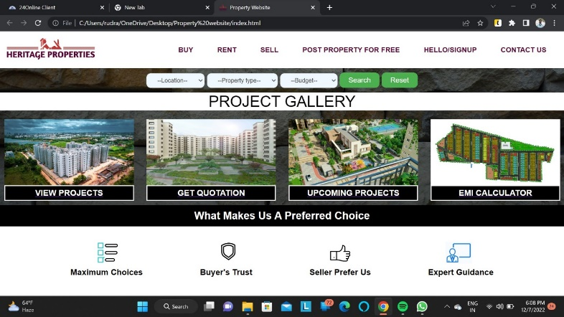

Screenshot of buy page (it will appear on clicking on buy on nav bar):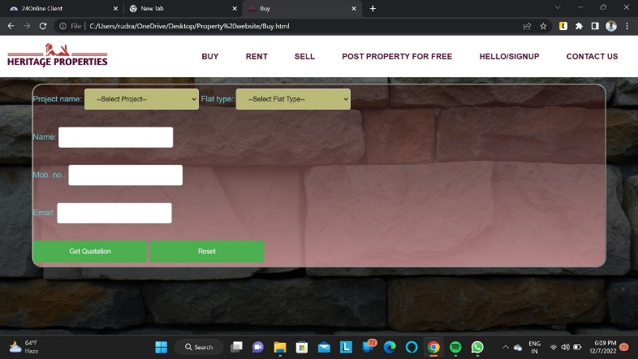

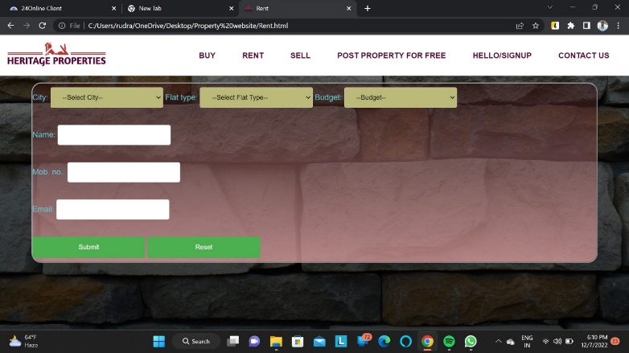

Screenshot of rent page (appears after clicking on rent option):

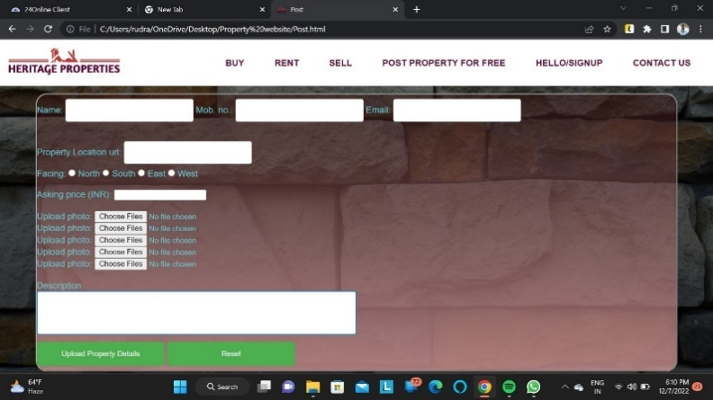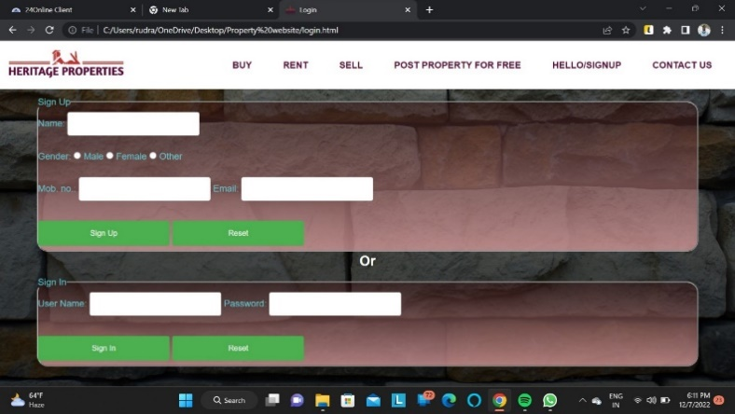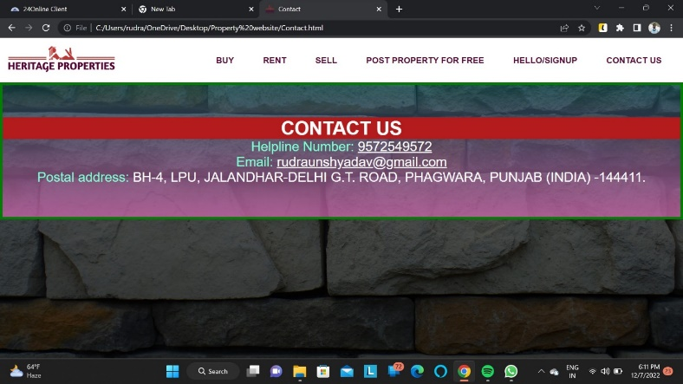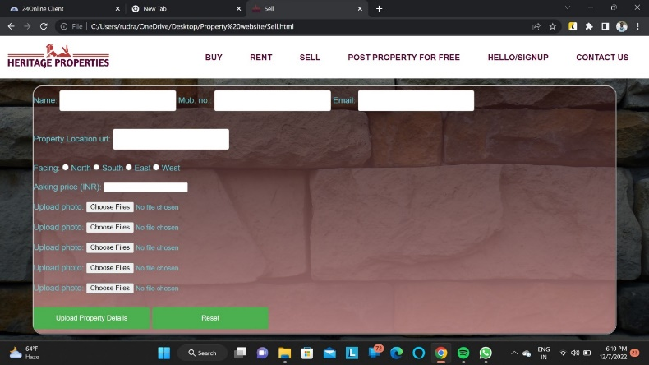

Screenshot of contact page (appears after clicking on the contact us option in the nav bar):

Screenshot of login page (appears after clicking on the hello/signup option in the nav bar)

Screenshot of post page (appears after clicking on the Post property for free option in the nav bar)

Screenshot of sell page (appears after clicking on the sell option in the nav bar)

FLOW OF PROJECT

The project based on Property Website has been assigned by our subject teacher, we were two in a group.

We both decided to do this project together because we can’t divide this project into two parts, since this project consists of two major portions HTML and CSS. Both HTML and CSS work together so we had to work together instead of deciding our role for this project.

To design and frame this website we first decided what we are going to include in this project and what will be our frame design. According to our desired design, we completed this project.

HTML ATTRIBUTES AND CSS USED

HTML ATTRIBUTES USED

Link, Div class, Href, Ul-li, Form, Select, Button, Figcaption, Legend, Radio, Email, Tel, Reset, Url, Myfile, Description

CSS USED

Margin, Padding, Font family, Box sizing, Linear gradient, Width, Height, Background – color, Display, Align – item, Justify content, Cursor, Position, Text transform, Transition, Hover, Color, Border radius, Font size, Grid

CONCLUSION

At first, we would like to thank your Pro. Salim for giving us this beautiful project, the purpose of this project is to use our theoretical knowledge in practice. We really enjoyed and learned many things during the completion of this project.

We implemented the our learnings in it and come to know how CSS works with HTML. CSS plays a major role in a webpage. With the help of CSS we designed our webpage.

This was an interesting project and taught us many things as we implemented many things in it. Now we are known to HTML, CSS and how they work together.

REFERENCES

As reference we took help from Class Notes, Google, YouTube and friend.

Class notes helped us in checking error in our html/css page.

We used Google to add some transition like hover effect in our web-page.

We didn’t took so much help from YouTube but once it helped in getting idea about how to design page and what steps should be taken.

We took help from our friends to find error, check for design whether it is fine or we have to improve it.